**Group 5:** Subhransu (Bron) Nanda,Pa Vang and Henrique Martha de Oliveira

**SEIS 610 Project Deliverable #1 (100 Project Points) Inception Phase (Project Kickoff)**

**The following artifacts from the inception phase must be complete and neatly done on the Confluence**

**Server.**

**1. Project Vision (10 points)**

a. This should be at least one paragraph, maximum two paragraphs. You should describe the main user story in this. This should be written in a ‘happy’ optimistic fashion.

GreenGo is a fun and educational game app to encourage users to recycle alkaline batteries at the proper collection points. It is compatible with both IOS and Android devices. It starts with the user creating an account and an Avatar and logging in into the app. Then the app shows a map with the user’s location along with the collection points close to the user’s geographical location. There’s also an option to use the Augmented Reality (AR) mode. The user then navigates to the recycling sites of his/her choice. The user can then take a picture of the batteries at the site to unlock a game for hunting bunnies which runs in the AR mode. Each bunny caught is 1 point. After getting 20 points, the user can then redeem coupons towards buying eco-friendly products. With rise in the game level, the user will unlock more amazing features, rewards and coupons.

**2. Project Boundaries (10 points)**

Boundaries with GreenGo:

1. It will be compatible with both IOS and Android devices.
2. It will have both the English and the Spanish language as an option.
3. It will be programmed in Python.
4. It will administer a real-time simulation.
5. It will come with a graphical user interface (GUI).
6. It will be released first in the state of Minnesota.

**3. Requirements written as User Stories (30 points)**

* As a consumer I want to learn the proper ways to recycle alkaline batteries so I can reduce the waste pollution. (100 tomatoes)
* As a social enterprise business owner, I want to empower eco-friendly consumers so that I can promote recycling. (90 tomatoes)
* As a business owner I want to provide coupons to consumers so that I can grow my clientele. (90 tomatoes)
* As a consumer I want to get points so I can get coupons to eco-friendly businesses I like. (80 tomatoes).
* As a kid I want to play the bunny game so I can get a lot of points and increase my levels. (100 tomatoes)

**4. Business Case and Initial Cost Estimate (20 points)**

a. Assign ‘points’ to your user stories and use cases based on ‘intuitive’ complexity.

|  |  |
| --- | --- |
| Description | Tomatoes |
| Teach how to properly recycle alkaline batteries, using GPS tools to alert about recycling stations | 100 |
| Give coupons to support eco-friendly consumers and maintain or acquire new customers | 180 |
| Track and store points/coupons for the bunny game | 80 |
| Create the AR platform with bunny game and also different levels | 100 |
| Total | 460 |

b. Make an arbitrary decision about how much each point is going to cost in hours. For example, you may say each point costs 4 hours.

c. Decide what your hour is worth and estimate the development cost.

We believe our total project will amount to 460 tomatoes.

1 tomato = 25 hours

25 hours *460 tomatoes = 11,500

We believe that our hourly rate comes to $25 per hour, therefore our total cost of labor comes to be $287,500.

d. Do a search for other similar existing software and note costs. (invent costs if you have to)

Green Go is similar to the games PokemonGo and Harry Potter: Wizards Unite.

Based off our research on similar existing softwares, we found that the estimated development cost would be about $450,000-$600,000.

<https://www.quora.com/How-much-did-it-cost-to-build-Pok%C3%A9mon-GO>

e. Include open source software that does a similar function and then describe what it is not suitable.

We could not find anything.

f. We believe the following are business risk for GreenGo:

* High development and maintenance costs
* Lack of users
* Lack of sponsors
* No business plan created
* No market or consumer research done

g. Identify cost in tools and other equipment you will need.

* Server- $1000 per month
* Computer with access to Python software
* AR application

Total estimated cost for tools and other equipment is $50,000.

**Conclusion**

We have decided to go forward with this idea for building the game GreenGo not only because it is economically viable for the long run but also because it encourages environment-friendly activities among the consumers and teaches them the concept of recycling. On top of that, we are closing the gap between consumers and local businesses in MN and advocating Green Entrepreneurship. It also allows us to get a decent profit for the growth of our brand and company.

**5. Identify Risks. (15 points)**

1. Engineers have no experience programming in python.
2. The app’s main concern is to have secure transactions while dealing with coupons.
3. Engineers have no experience with security and different processes in IOS or Android devices.
4. Engineers have no experience in storing data for the app.
5. Engineers have no experience with creating a GUI.
6. Engineers have limited knowledge with the functioning of GPS.
7. Engineers have limited experience in the recycling or environmental sphere.
8. Engineers have no experience with data security or privacy.
   1. Private information of users shared with the business partners needs to be protected.

**6. Candidate Architecture (5 points)**

**a.** This will be expanded dramatically during the other phases, but for inception simply describe what do you expect to this product to run on and how you envision it may work. **Draw a block diagram.**

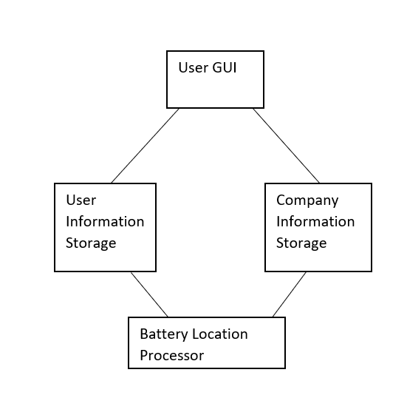

**7. Non-functional requirements (5 points) (Often called FURPS in Rational Unified Process)**

* It will require frequent GPS map updates.
* It will have security and privacy.

8. **Glossary**. (5 points)

a. You must include a complete glossary of terms. The glossary will be expanded as we go.

1. User: The person creating an account and an Avatar to play the game
2. Businesses: The commercial establishments including local businesses in MN giving coupons to users each time they receive 20 points.
3. Bunny hunt game: A special feature game that unlocks after a user recycles the alkaline batteries at the collection points.
4. Bunny points: The tracking system for the users to collect coupons.
5. Battery collection site: A place that recycles used batteries which the user can use to get points and unlock the bunny hunt game.